Call for paper

to participate in the following event in spring 2020:
Faculty of Business and Economics’s
Scientific Student’s Association’s Conference

The University of Pannonia’s Faculty of Business and Economics, along with its institutions, departments, as well as its teaching locations, with the support of the Scientific Student’s Council of the University of Pannonia and the University of Pannonia Faculty of Business and Economics’ Scientific Student’s Council announces the Institutional Scientific Student’s Association’s Conference at the University of Pannonia.

Students enrolled at BSc/BA, MSc/MA programmes can be qualified to participate.
The application has to be done via online registration with a short summary of the research paper handed in on the following website: http://etdk.uni-pannon.hu.

Important dates/deadlines:
- the date of the 2019 Institutional Scientific Student’s Association’s conference: 5th May 2020 (online conference)
- the deadline for registration and submission of the short summary: 3rd April 2020, 10:00 PM
- submission deadline for the final paper online: 24th April 2020, 12:00PM
Formal requirements and other information can be found on the websites of the different faculties (login first to Moodle): https://moodle.gtk.uni-pannon.hu/course/view.php?id=4814

Sasné Dr. Grósz Annamária Dr. Raffay-Danyi Ágnes Nóra
President of the Scientific Student’s Association at President of the Scientific Students’ Associations
the University of Pannonia at the Faculty of Business and Economics,
University of Pannonia

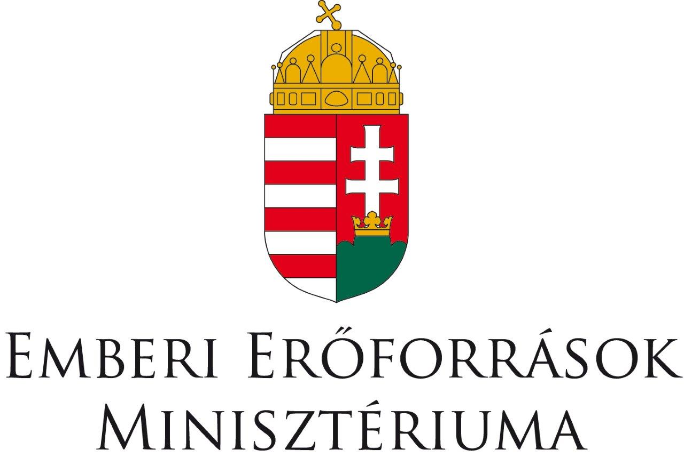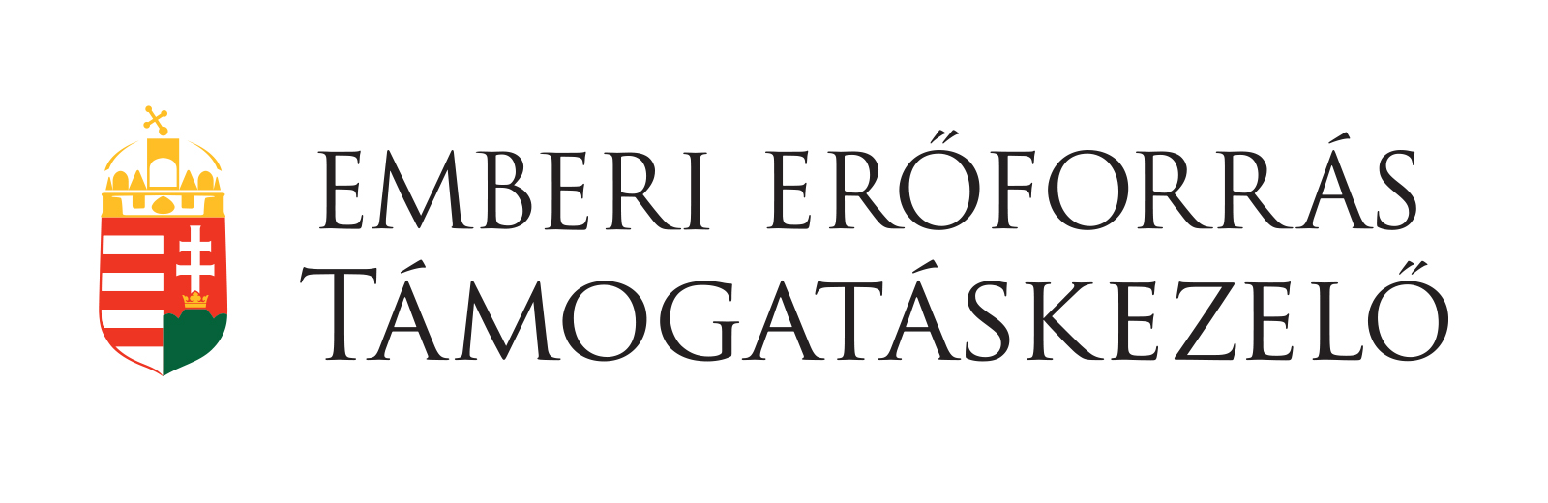
A program a Pannon Egyetem Gazdaságtudományi Kara által elnyert az Emberi Erőforrás Támogatáskezelő által támogatott „A hazai Tudományos Diákköri műhelyek és rendezvényeik” című projekthez (NTP-HHTDK-19-0018) kapcsolódóan valósul meg.

